# Experiment No : 1

**Name :** Samadhan Chandrakant Kadam **Roll No :** 20244346 **Title :** Java Program Based on Branching And Looping Statements **1)Break statement:**

## Program:

package branching_statements; public class break_statement {

public static void main(String[] args )

{int[]numbers ={1,2,3,4,5,6,7,8,9,10};

for(int num : numbers)

{

if (num == 5)

{

break;

}

System.out.println(num);

}

}

}

**Output:**

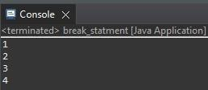

1. **continue statement:**

## Program:

package branching_statements; public class continue_statement

{

public static void main(String[] args) { for (int i = 1; i<=10; i++)

{

if (i % 2 == 0)

{

continue;

}

System.out.println(i);

}

}

}

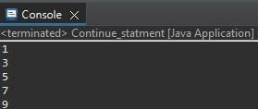**Output:**

1. **return statement:**

## Program:

package branching_statements; public class return_statement

{

public static void main(String[] args){ int n = 16;

long Factorial = calculatefactorial(n); System.out.println("factorial of "+n+" is "+Factorial);

}

public static long calculatefactorial(int n)

{

if (n == 0|| n == 1)

{

return 1;

}

else

{

}

}

}

return n* calculatefactorial (n-1);

**Output:**



1. **while loop:**

## Program:

package looping_statements; public class while_loop

{

public static void main(String[] args) { int i = 1;

while (i<=5)

{

System.out.println("Hello"); i++;

}

}

}

**Output:**

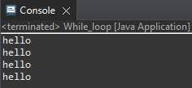

1. **do-while loop:**

## Program:

package loop;

public classdo_while_loop

{ public static void main(String[] args) { int i=1; do

{

System.out.println (i); i++;

}while(i<=5);

}

}

**Output:**

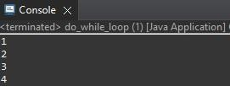

1. **for loop:**

## Program:

package looping_statements; public class for_loop {

public static void main(String[] args) { int n = 5;

for(int i = 1; i<=n; ++i)

{

System.out.println("BCA");

}

}

}

**Output:**

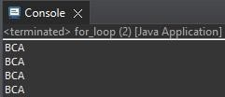

1. **switch case:**

## Program:

package statement; public class switch_case

{ public static void main(String[] args)

{

int number = 4; switch(number)

{

case 1: System.out.println("1"); break;

case 2: System.out.println("2"); break;

case 3: System.out.println("3"); break;

case 4: System.out.println("4"); break;

case 5: System.out.println("5"); break;

}

default : System.out.println("Number present in the 1 to5");

}

}

**Output:**

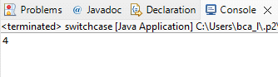

# Experiment No : 2

**Name:** Samadhan Chandrakant Kadam **Roll No:** 20244346

**Title :** Java program based on Type casting.

**Implicit Casting:**

package Casting;

public class implicit_casting {

public static void main(String[] args)

{

int a=5; float b=a;

System.*out*.println("Float value is:"+b);

}

}

**Output:**

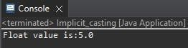

**Explicit Casting:**

package Casting;

public class Emplicit_casting

{

public static void main(String[] args)

{

double d=35.5; int i=(int)d; float f=(float)d; long l=(long)d; short s=(short)d; byte b =(byte)d;

System.*out*.println("Double value:"+d); System.*out*.println("int value:"+i); System.*out*.println("float value:"+f); System.*out*.println("long value:"+l); System.*out*.println("short value:"+s); System.*out*.println("byte value:"+b);

}

}

**Output:**

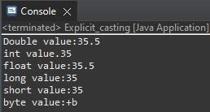

# Experiment No :3

**Name:** Samadhan Chandrakant Kadam **Roll No :** 20244346

**Title :** Java program based on command line arguments.

**Command line Argument:**

package cmd_line_arguments;

public class command_line_arguments

{ public static void main(String[] args)

{

for(int i=0; i<args.length; i++)

{

System.*out*.println("I Am "+args[i]);

}

System.*out*.println("Total no of command line arguments is : "+args.length);

}

}

**Output :**

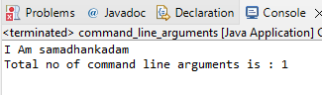

# Experiment No : 6

**Name:** Samadhan Chandrakant Kadam **Roll No:** 20244346

**Title :** Java program based on method overloading.

**Program:** package method; class SumDemo

{

int sum(int x,int y)

{

return(x+y);

}

int sum(int x,int y,int z)

{

return(x+y+z);

}

double sum(double x,double y)

{

return(x+y);

}

}

public class method_overloading {

public static void main(String[] args)

{

SumDemo s=new SumDemo(); System.out.println(s.sum(12,23)); System.out.println(s.sum(15,20,50)); System.out.println(s.sum(25.50,10.40));

}

}

**Output:**

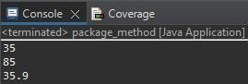

# Experiment No : 7

**Name:** Samadhan Chandrakant Kadam **Roll No :** 20244346

**Title :** Java program based on method overriding.

**Program:** package method; class Super

{ int x;

Super(int x)

{

this.x=x;

}

void display()

{

System.out.println("Super x="+x);

}

}

class Sub extends Super

{

int y;

Sub(int x,int y)

{

super(x);

this.y=y;

}

void display()

{

System.out.println("Super x="+x); System.out.println("Sub y="+y);

}

}

public class method_overriding {

public static void main(String[] args)

{

Sub s1=new Sub(200,300); s1.display();

}

}

**Output:**

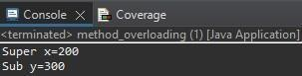

**Experiment No : 8 Name:**Samadhan Chandrakant Kadam **Roll No:**20244346 **Title :** Java program based on interfaces.

## Program:

package inheritance; class Student

{

int roll_number;

public void get_roll_number(int rn)

{

roll_number=rn;

}

public void put_roll_number()

{

System.out.println("Roll Number:-"+roll_number);

}

}

class Test extends Student

{

Double sem1_marks, sem2_marks;

public void get_marks(double m1,double m2)

{

sem1_marks=m1; sem2_marks=m2;

}

public void put_marks()

{

System.out.println("marks Obtained:"); System.out.println("Semester-1:"+sem1_marks); System.out.println("Semester-2:"+sem2_marks);

}

}

interface sports_marks

{

double sports_points=2.0; public void put_sports_points();

}

class Result extends Test implements sports_marks

{

double total_marks;

public void put_sports_points()

{

System.out.println("Sports marks:"+sports_points);

}

public void Display()

{

total_marks=sem1_marks+sem2_marks+sports_points; put_roll_number();

put_marks();

put_sports_points();

System.out.println("Total marks:"+total_marks);

}

}

public class multiple_inheritance {

public static void main(String[] args)

{

Result ob=new Result(); ob.get_roll_number(123); ob.get_marks(76.56,87.12);

ob.Display();

}

**Output:**

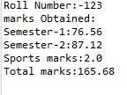

# Experiment No : 9

**Name :** Samadhan Chandrakant Kadam **Roll No:** 20244346

**Title :** Java program based on packages.

**Program:** package pack; public class A

{

public void msg()

{System.out.println("Hello");

}

}

**Package B:** package Mypack; import pack.*; public class B

{

public static void main(String args[])

{

A obj=new A(); obj.msg();

}

}

**Output:**

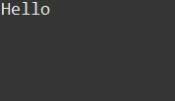

# Experiment No : 11

**Name :** Samadhan Chandrakant Kadam **Roll No :** 20244346

**Title :** Java program based on Exception Handling.

1. **try-catch block:**

## Program:

package java_exception;

//try-catch block

public class JavaExceptionExample

{

public static void main(String args[])

{

try

{

int data=100/0;

}

catch(ArithmeticException e)

{

System.out.println(e);

}

System.out.println("rest of the code ");

}

}



# Output:

1. **try-catch-finally block:**

## Program:

package java_exception;

public class FinallyBlock

{

public static void main(String args[])

{

try

{

int data=25/5; System.out.println(data);

}

catch(NullPointerException e)

{

System.out.println(e);

}

finally

{

System.out.println("finally block is always executed");

}

System.out.println("rest of the code... ");

}

}

**Output:**

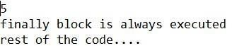

# Experiment No : 4

**Name :** Samadhan Chandrakant Kadam **Roll No :** 20244346

**Title :** Java program based on constructors.

**Default Constructor:**

**Program:** Packageconstructo; class

Bike1

{ Bike1()

{

System.out.println("Bike is Created");

}

} public class default_constructor {

public static void main(String[] args)

{ Bike1 b=new Bike1();

}

}

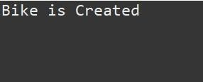**Output:**

**Parameterized Constructor :**

## Program:

package constructor; class Student4 {

int id;

String name; Student4(int i,String n)

{

id = i; name = n;

} void display()

{

System.out.println(id+""+name);

}

}

public class parameterized_constructor

{

public static void main(String[] args) {

Student4 s1 = new Student4(111 , " Karan "); Student4 s2 = new Student4(222 , " Aryan ");

s1.display();

s2.display();

}

}

**Output:**

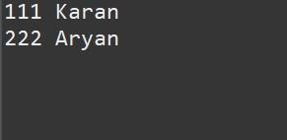

# Experiment No : 5

**Name :**Samadhan Chandrakant Kadam **Roll No:**20244346 **Title :** Java program based on inheritance.

**Single inheritance:**

## Program:

package inheritance; class Animal

{

void eat()

{

System.out.println("eating...");

}

}

class Dog extends Animal

{

void bark()

{

System.out.println("barking...");

}

}

public class single_inherritance

{

public static void main(String[] args)

{

d.bark();

}

}

**Output:**

Dog d=new Dog(); d.eat();

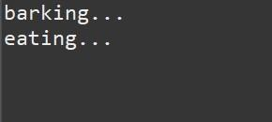

**Multilevel inheritance:**

## Program:

package inheritance; class Animal

{

void eat()

{

System.out.println("eating...");

}

}

class Dog extends Animal

{

void bark()

{

System.out.println("barking...");

}

}

class BabyDog extends Dog

{

void weep()

{

System.out.println("weeeping");

}

}

public class multilevel_inheritance {

public static void main(String[] args)

{

d.weep();

}

}

**Output:**

BabyDog d=new BabyDog();

d.bark();

d.eat();

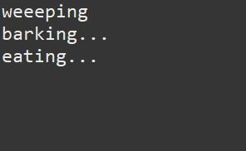

**Hierarchical inheritance:**

## Program:

package inheritance; class A

{

public void print_A()

{

System.out.println("Class A");

}

}

class B extends A

{

public void print_B()

{

System.out.println("Class B inherits from class A");

}

}

class C extends A

{

public void print_C()

{

System.out.println("Class C inherits from class A");

}

}

class D extends A

{

public void print_D()

{

System.out.println("Class D inherit from class A");

}

} public class hierarchical_inheritance

{

public static void main(String[] args)

{

B obj_B=new B(); obj_B.print_A(); obj_B.print_B();

C obj_C=new C();

obj_C.print_C();

D obj_D=new D();

obj_D.print_D();

}

**Output:**

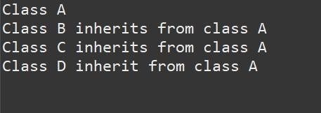

# Experiment No : 10

**Name :** Samadhan Chandrakant Kadam **Roll No :** 20244346

**Title :** Java program Based on Multithreading

## Program :

package multithreading;

class NumberPrinter extends Thread

{

private String threadName;

public NumberPrinter(String name)

{

this.threadName = name;

}

public void run()

{

for(int i = 1; i<=5; i++)

{

System.out.println(threadName +"-Number:"+i); try

{

Thread.sleep(500);

}catch(InterruptedException e)

{

System.out.println(threadName +"interrupted");

}

}

System.out.println(threadName + "has finished executing");

}

}

public class multithreading_program { public static void main(String[] args)

{

NumberPrinter thread1 = new NumberPrinter("Thread 1"); NumberPrinter thread2 = new NumberPrinter("Thread 2");

thread1.start(); thread2.start();

try {

thread1.join();

thread2.join();

}catch(InterruptedException e) {

System.out.println("All threads have finished executing");

}

}

}

# Output:

**Thread Life Cycle**

## Program :

package multithreading;

class MyThread extends Thread

{

public void run()

{

state");

try { System.out.println(Thread.currentThread().getName()+"is in Runnable Thread.sleep(100);

synchronized (this)

{

Blocked state");

System.out.println(Thread.currentThread().getName() + " is in Thread.sleep(200);

}

System.out.println(Thread.currentThread().getName() + " is terminating");

}

catch(InterruptedException e)

{

System.out.println(Thread.currentThread().getName()+"was intrrepted");

}

}

}

public class thread_life_cycle

{

public static void main(String[]args)

{

MyThread thread1=new MyThread(); MyThread thread2=new MyThread();

System.out.println(thread1.getName()+"is in New state"); thread1.start();

System.out.println(thread2.getName()+"is in New state"); thread2.start();

try {

Thread.sleep(50);;

System.out.println("Main thread is in Waiting state"); synchronized(thread1)

{

thread2.join();

System.out.println(thread2.getName()+"has finished executing");

}

catch (InterruptedException e)

{

System.out.println("Main thread was intrrupted");

}

System.out.println("Main thread was terminating");

}

}

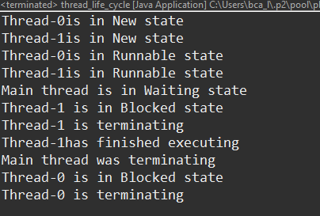**Output:**